Release Note - **Document Checklist Management**

Quarterly Product Release

Version 24.1.0.0



C

ONTACTS

info@uppwise.com

[LinkedIn Company Profi](https://www.linkedin.com/company/uppwise)le

[www.uppwise.c](http://www.uppwise.com/)om

Quarterly Product Release Version 23.3.0.1



C

ONTACTS

info@uppwise.com

[LinkedIn Company Profi](https://www.linkedin.com/company/uppwise)le

[www.uppwise.c](http://www.uppwise.com/)om

This serves as a Feature Release Note to apprise our customers of the latest addition to the application, released with the Uppwise 2024 **Quarter 1 release 24.1.0.0**

# Feature: Document Checklist Management

Introducing New Features for Enhanced Workflow Management Via Document Checklist Management

**Form Builder Configuration:**

* Easily configure your initiative forms by navigating to the company settings and accessing the form builder.
* Select the initiative form you're working with and access additional options via the menu icon.
* Enable the "Checklist Management" tab to activate document management, allowing you to choose the document process that fits your needs.

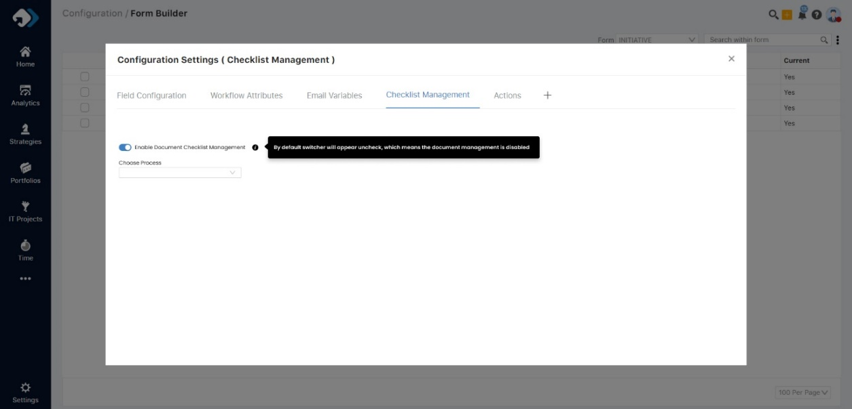

**Checklist Creation in Initiative Workflow:**

* Add a new "Checklist Creation" tab to streamline workflow configuration within initiatives.
* Define trigger conditions for automatic object creation, including workflow attributes, conditions, and values.
* Access the Object Control Popup to add multiple entries, specifying titles, weights, mandatory status, DFS structure, and defaults.
* Ensure smooth object creation processes, with conditions executed one at a time and automatic creation of objects based on defined conditions.

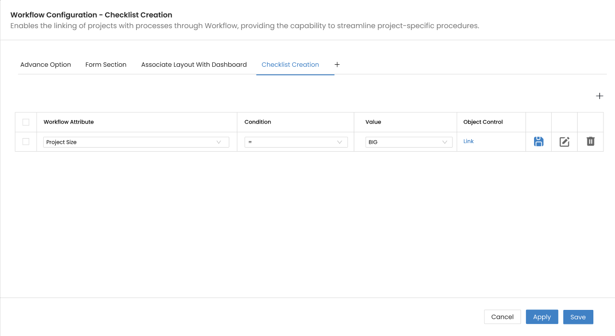

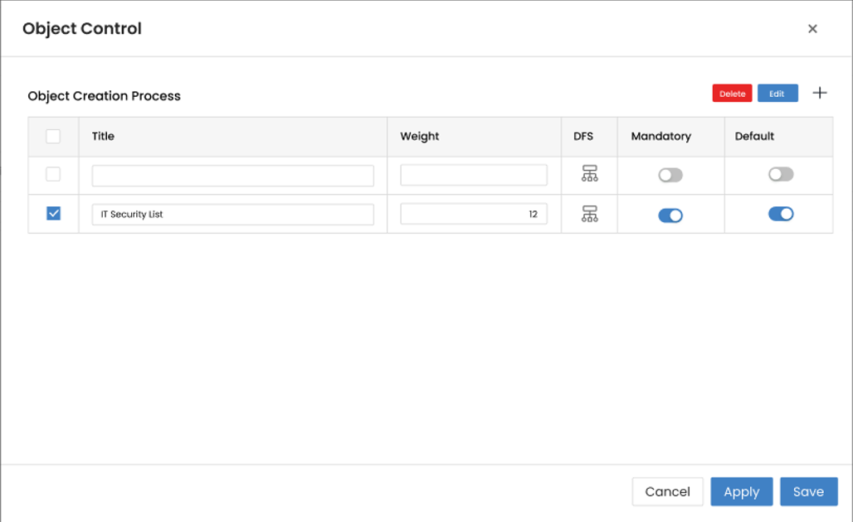

**Analytics Dashboard Integration:**

* All required custom fields are now integrated into the data source.
* Future custom field additions will be easily accommodated, enhancing flexibility and scalability.

**Threshold Setting:**

* Manage thresholds for computing KPIs, enhancing document management efficiency.
* Display document status threshold settings on the status report, previously available only in the health widget, integrating colour indicators for enhanced project health visualization.
* Weight and the Status field will be used to calculate the KPI colour based on the formula provided in below table.

**Key Appear Over Portfolio:** Need to add one column named as document over the project status update on portfolio which will show the key data over the same.